**Entity Class Diagram**

The following Class Diagram has been designed to support six major aspects of functionality within the system. In developing the diagram I focused on the following areas: customer registration & login, address management, managing the basket, ordering, table reservation and payment processing.

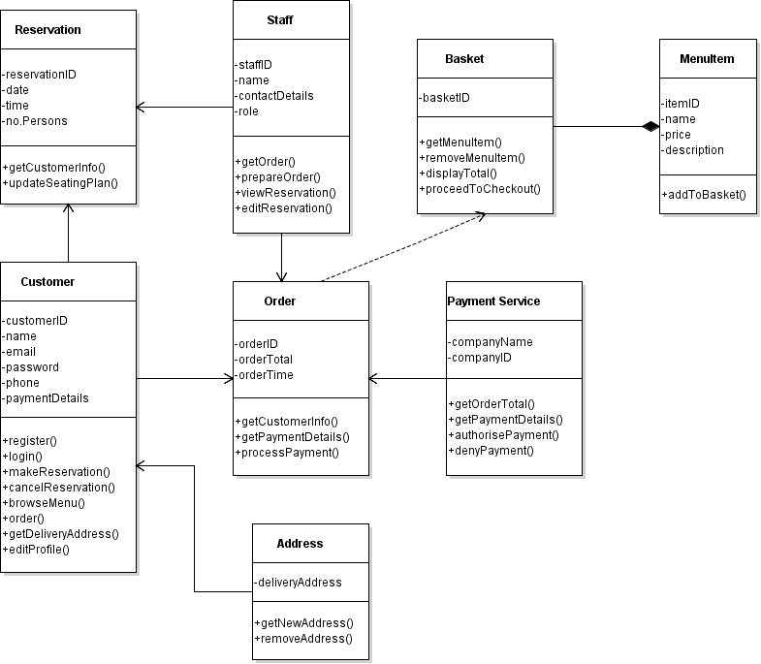

The customer registration and login functions are contained within the Customer class as methods. We have added the possibility of having multiple addresses stored for each customer as extra functionality in this phase and as such there is now an Address class that will hold this data and interact with the Customer class.

The Basket class includes methods for adding and removing items and is associated with the MenuItem class which stores item attributes.

Following on from that we have the Order class which has relationships with the Customer, Staff and Payment Service classes. The Order has methods to get Item details from Basket, get customer information for delivery, get payment details and interacts with Staff. Payments are processed by a third party company and so the system interacts with the Order and Customer classes to provide relevant information.

Finally we have a Reservation class to manage table reservations, this interacts with both the Customer class to obtain necessary information and the Staff class for employee side management.

**Test Case - Registration**

**Test Case #:** 1 **Test Case Name:** Registration

**System:** Japanese Takeout **Design Date:** 25/04/2016

**Short Description:** Test registration function for new users

**Pre-conditions:**

* The system displays the home page

|  |  |  |  |  |
| --- | --- | --- | --- | --- |
| **Step** | **Action** | **Expected System Response** | **Pass/ Fail** | **Comment** |
| 1 | Click the 'Register' button | The system loads the registration page |  |  |
| 2 | Fill out required fields correctly with new data | The system validates the user input and proceeds to check database for existing entries. User info is unique, user is registered and system displays the confirmation page. An email is sent to user’s email address. |  |  |
| 3 | Input incorrect data into registration form | The system displays error: “Invalid input, please re-enter your details” |  |  |
| 4 | Fill out form with details of a previously registered user | The system displays error: “Email address already in use. Please enter an alternate email or login to continue” |  |  |

**Post-conditions:**

1. The new customer’s details are saved in the database containing the attributes given in the Entity Class diagram such as name, email address, phone number, delivery address and payment details.

**Sequence Diagram – User Registration**

